**FUNDAMENTALS OF SOFTWARE ENGINEERING**

**(CS-2004)**

**Project Name: BookStore Management System**

**Team Name:** **Infinity Coders**

**Group Members:**

* **Sarita Sangrez (23i-2088)**
* **Syeda Shanzay Shah (23i-2016)**
* **Laiba Nasir (23i-2079)**

**Deliverable Number: 2**

**Date of Submission: 26th March 2025**

1. **Project Title: LexiShop-BookStore Management System**
2. **Introduction:**

The Book Management System is designed to provide users with a seamless and efficient way to search for and read books online. This system addresses the challenge of finding books across different categories by offering an intuitive search functionality based on genre, author, and title.

The platform supports both guest and registered users, with purchasing privileges restricted to registered users. To enhance user experience, the catalogue is well-organized for easy browsing and integrates a secure payment system to ensure safe transactions.

The scope of this project includes book listing, searching for books, placing orders, and managing inventory. However, it does not support book rentals or integration with physical bookstores. By providing a user-friendly interface and a secure transaction process, the system aims to cater to book enthusiasts, making book discovery and purchasing effortless.

1. **User Stories:**

USER STORY: 01

|  |  |  |  |  |
| --- | --- | --- | --- | --- |
| |  | | --- | | **IMPORTANCE:**  ***5*** |   **STORY ID**: *US-01* **STORY TITLE**: ***View Bookstore Homepage***     **USER STORY**:   |  | | --- | | **As a**: User  **I want:** to view the bookstore homepage.  **so that:** I can browse available books and navigate the site easily. |  |  | | --- | | **ESTIMATE:**  ***3*** |      |  | | --- | | * And I know I am done when I can see a homepage displaying book categories and featured books. * And I know I am done when I can navigate to different sections of the site from the homepage. |   **ACCPETANCE CRITERIA TYPE:**   ***Search***   ***View*** |

USER STORY: 02

|  |  |  |  |  |
| --- | --- | --- | --- | --- |
| **STORY ID**: *US-02* **STORY TITLE**: ***Admin Login***    **USER STORY**:   |  | | --- | | **As a**: Admin  **I want:** I want to log into the system. **so that:** I can manage books. |  |  | | --- | | **IMPORTANCE:**  ***5*** |  |  | | --- | | **ESTIMATE:**  ***4*** |      |  | | --- | | And I know I am done when I can enter my admin credentials and access the admin dashboard.  And I know I am done when unauthorized users cannot log into the admin panel. |   **ACCPETANCE CRITERIA TYPE:**   ***Workflow***   ***Manage Data*** |

USER STORY: 03

|  |  |  |  |  |
| --- | --- | --- | --- | --- |
| **STORY ID**: *US-03*  **STORY TITLE**: **Admin Can Add Books**    **USER STORY**:   |  | | --- | | **As a**: Admin  **I want:** to add books to the bookstore.  **so that:** users can see and purchase them. |  |  | | --- | | **IMPORTANCE:**  **4** |  |  | | --- | | **ESTIMATE:**  **5** |      |  | | --- | | * And I know I am done when I can input book details (title, author, price, category) and save them in the system. * And I know I am done when users can view newly added books in the bookstore. |   **ACCPETANCE CRITERIA TYPE:**   ***Manage Data***   **Report/View** |

USER STORY: 04

|  |  |  |  |  |
| --- | --- | --- | --- | --- |
| |  | | --- | | **IMPORTANCE: *4*** |   **STORY ID**: *US-04* **STORY TITLE**: ***Search for Books***    **USER STORY**:   |  | | --- | | **As a**: Admin  **I want:** to search for books by title, author, or category. **so that:** I can easily find what I’m looking for. |  |  | | --- | | **ESTIMATE:**  ***3*** |      |  | | --- | | * And I know I am done when I can enter a search term and see relevant book results. * And I know I am done when search filters help refine my results. |   **ACCPETANCE CRITERIA TYPE:**   ***Search***   ***Workflow*** |

1. **Structured specifications:**

**User Story 1: View Homepage**

|  |  |
| --- | --- |
| Title | As a user, I want to view the bookstore homepage so that I can browse available books and navigate the site easily. |
| Function | View Homepage |
| Description | Displays the bookstore homepage with book categories, featured books, and navigation options. |
| Inputs | None |
| Source | User opens the website through a browser. |
| Outputs | Homepage layout with book listings and navigation links. |
| Destination | User interface (homepage view) |
| Action | Load homepage content and render the UI. |
| Requirements | A working internet connection and an accessible server. |
| Pre-Condition | The website is deployed and running. |
| Post-Condition | The user sees the homepage with books and navigation options. |
| Side Effects | Loading time may vary depending on the internet speed. |

**User Story 2: Admin Login**

|  |  |
| --- | --- |
| **Title** | **As an admin, I want to log into the system so that I can manage books.** |
| **Function** | Admin Login |
| **Description** | Allow the admin to log into the system to access admin functionalities. |
| **Inputs** | Admin username, Password |
| **Source** | Admin submits login form via the UI. |
| **Outputs** | Login success message or error message (invalid credentials). |
| **Destination** | Admin panel (UI), database (admin session) |
| **Action** | Verify admin credentials, create session, and load admin panel. |
| **Requirements** | Valid admin credentials must exist in the database. |
| **Pre-Condition** | The admin is registered in the system. |
| **Post-Condition** | Admin is logged in and can manage the bookstore. |
| **Side Effects** | None |

**User Story 3: Admin Can Add Books**

|  |  |
| --- | --- |
| **Title** | **As an admin, I want to add books to the bookstore so that users can see and purchase them.** |
| **Function** | Add Books |
| **Description** | Allows the admin to add new books to the inventory. |
| **Inputs** | Book title, author, category, price, stock quantity, description |
| **Source** | Admin fills out the add-book form via the UI. |
| **Outputs** | Success message (book added) or error message (invalid input). |
| **Destination** | Database (book record), admin panel (updated book list) |
| **Action** | Save book details in the database and update the inventory. |
| **Requirements** | The admin must be logged in and have proper permissions. |
| **Pre-Condition** | Admin is authenticated and connected to the server. |
| **Post-Condition** | A new book appears in the bookstore catalog. |
| **Side Effects** | None |

**User Story 4: Admin Can Search Books**

|  |  |
| --- | --- |
| **Title** | **As an admin, I want to add books to the bookstore so that users can see and purchase them. As an admin, I want to search for books so that I can manage bookstore inventory efficiently.** |
| **Function** | |  | | --- | | Admin Book Search Panel | |
| **Description** | Allow admins to search for books in the bookstore database using various criteria |
| **Inputs** | |  | | --- | | Book title, author, ISBN, or category | |
| **Source** | |  | | --- | | Admin submits a search query via the UI. | |
| **Outputs** | List of matching books or a message indicating no results found. |
| **Destination** | |  | | --- | | User interface (search results) | |
| **Action** | Query the database for books matching the search criteria and display results. |
| **Requirements** | Books must be stored in the database. |
| **Pre-Condition** | |  | | --- | | The admin is logged into the system. | |
| **Post-Condition** | Search results are displayed, allowing the admin to view or manage books. |
| **Side Effects** | None |

1. **Scrum Board:**

Link to Scrum Board: <https://trello.com/b/k2hArLrM/bookstore-management-systemse>

1. **Snapshot 1 (Sprint Start):** After setting up the backlog and tasks

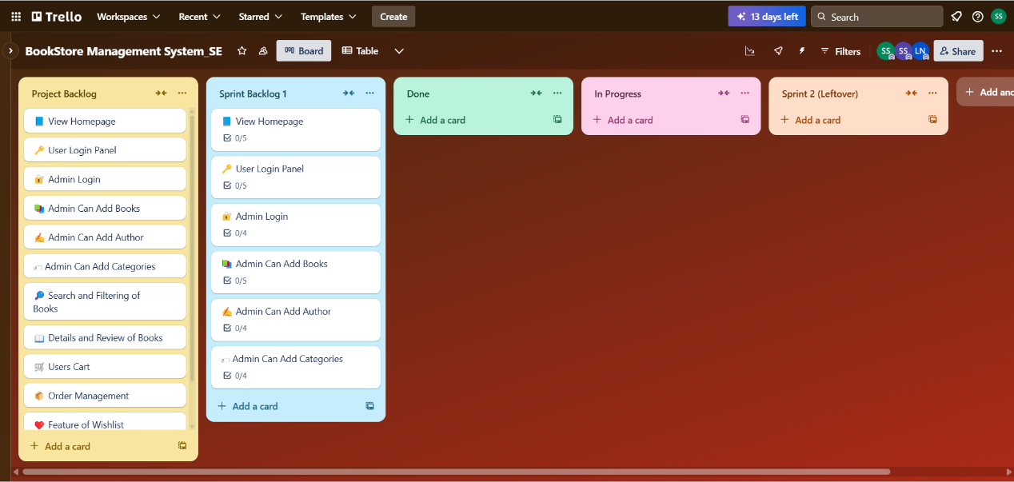



1. **Snapshot 2 (Mid-Sprint):** After completing ~50% of tasks



1. **Snapshot 3 (Sprint End):** Show completed features



**Burndown Chart:**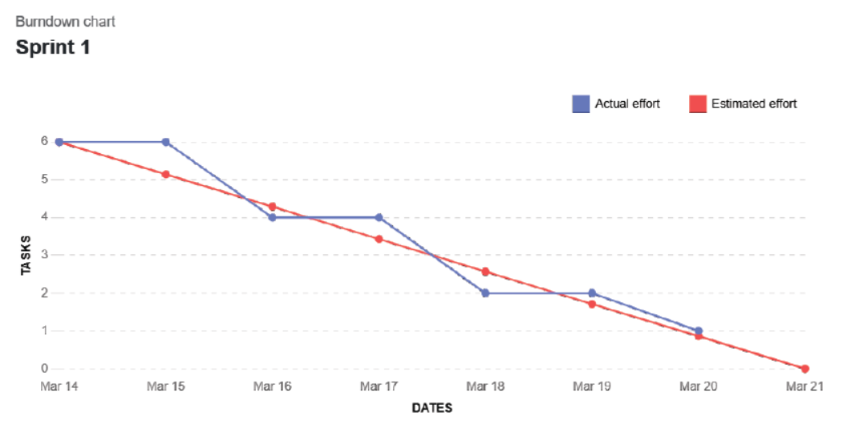

1. **NFR Specification using natural language specification:**
2. **Performance Requirements:**

* The homepage should load within 3 seconds for most users.
* The system should handle up to 100 users at the same time without slowing down.
* Search results should appear within 2 seconds after a query.

1. **Security Requirements:**

* User data, like passwords and payment details, must be encrypted for safety.
* The system should use secure tokens (JWT) for login authentication.
* After 5 failed login attempts, the system should temporarily lock the account and notify the user.

1. **Usability Requirements:**

* The website should work well on desktops, tablets, and phones.
* Users should be able to reach any main feature within 3 clicks.
* Error messages should be clear and helpful so users can fix issues easily.

1. **Availability Requirements:**

* The system should be available 99.5% of the time, except for maintenance.
* If the server fails, the system should switch to a backup within 5 minutes.

1. **Maintainability Requirements:**

* The system should be modular, so updates and new features don’t break existing functions.
* Important actions (like admin changes) should be logged for tracking and debugging.

1. **Scalability Requirements:**

* The system should handle more users and books as the bookstore grows.
* The database should manage up to 1 million books smoothly.

1. **Iteration 1 implementation screen shots:**
2. **Home Page:**

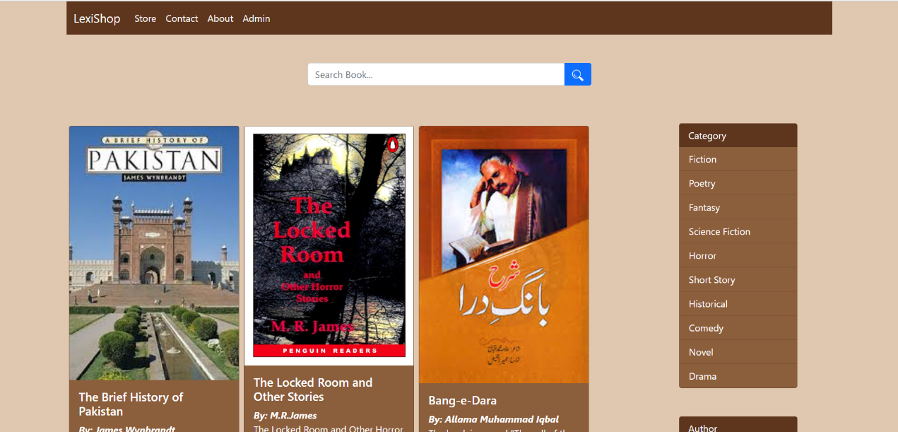

1. **Login Page for Admin:**

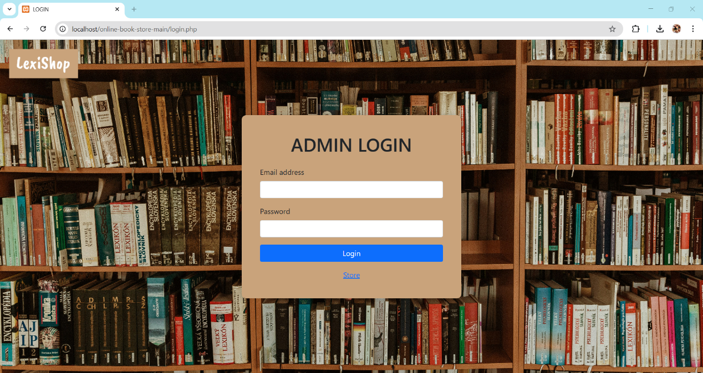

1. **Admin Panel:**

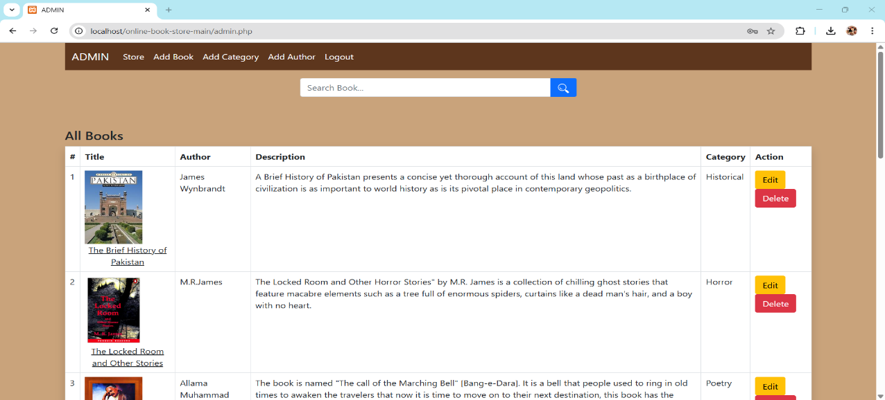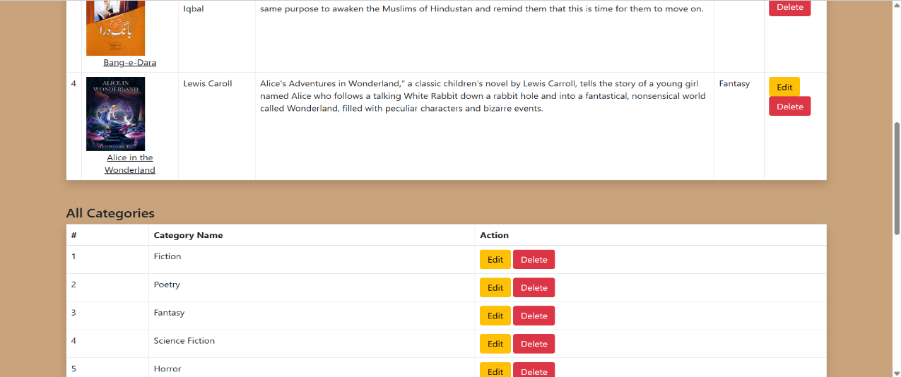

1. **Adding Book Feature:**

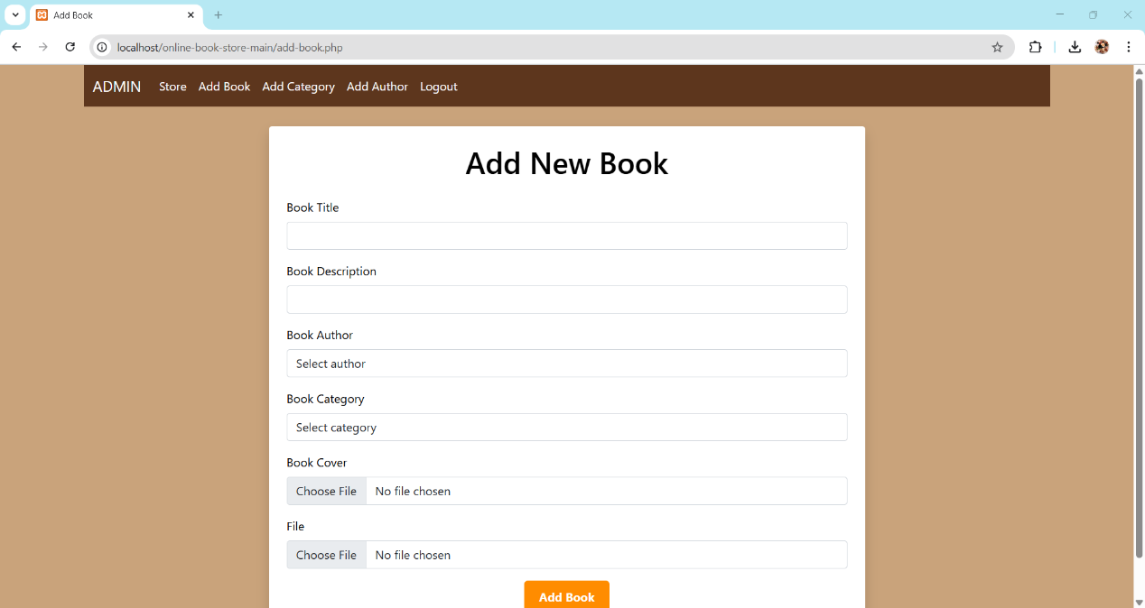

There are error/successful messages as well once the addition is success or failure. Additionally, admin can edit/delete a book as well from database.

1. **Adding Author Feature:**

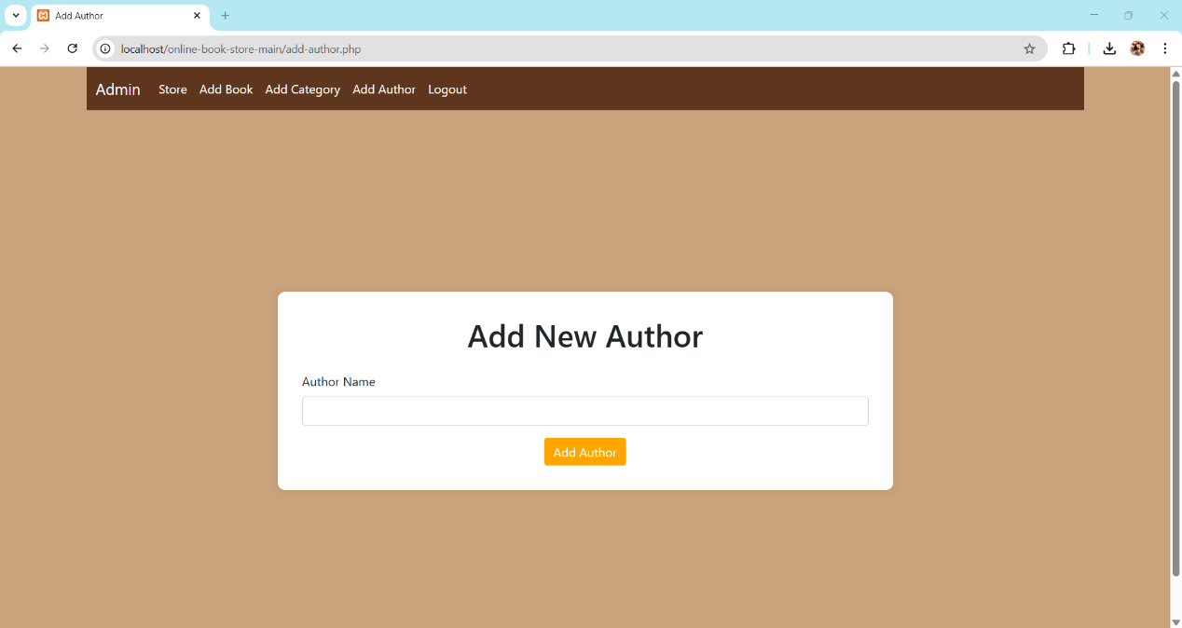

There are error/successful messages as well once the addition is success or failure. Additionally, admin can edit/delete an author name as well from database.

1. **Adding Category/Genre Feature:**

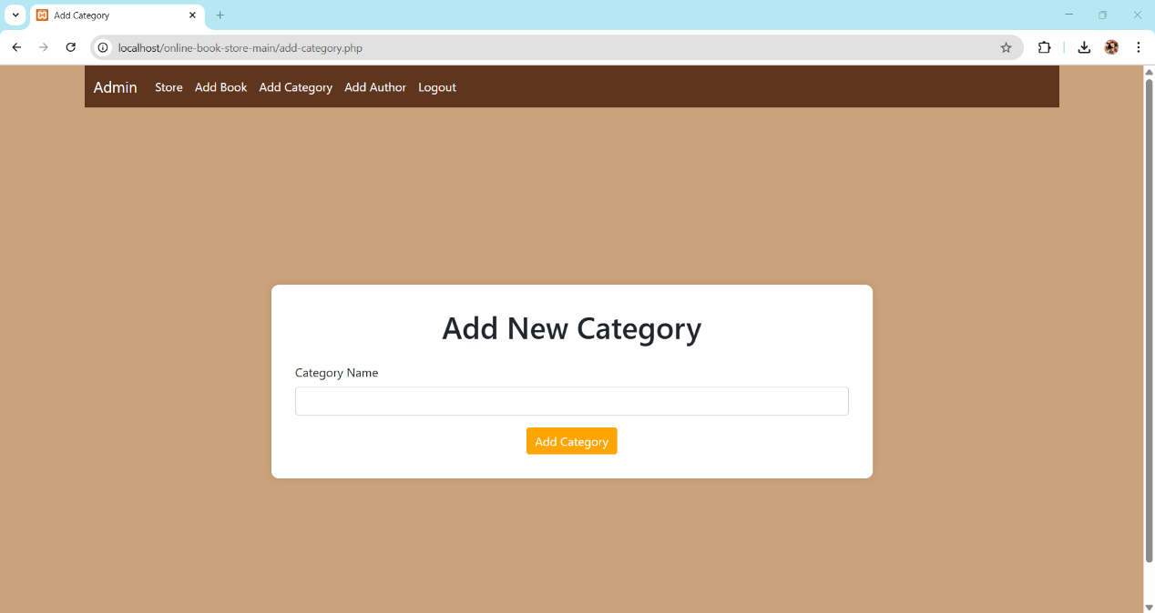

There are error/successful messages as well once the addition is success or failure. Additionally, admin can edit/delete category as well from database.

1. **Work division:**

|  |  |  |
| --- | --- | --- |
| Team Members | Roles/Responsibilities | Tasks |
| Shanzay | Backend Developer | * Create the homepage view * Implement user and admin login panel * Manage Trello board * Set up database for books and admin records * Implement admin login and book addition feature |
| Laiba | Tester & Documentation Manager | * Prepare documentation (Sprint backlog, NFRs, etc.) * Take screenshots for Sprint 1 progress * Analyse user stories * Structured specification of user stories |
| Sarita | Frontend Developer | * Design homepage layout and navigation * Create login and admin panels * Style pages (HTML/CSS) for responsiveness |